Cloud Storage: Qwik Start - Console
30 minutes1 Credit

Rate Lab

GSP073

Overview
Google Cloud Storage allows world-wide storage and retrieval of any amount of data at any time. You can use Google Cloud Storage for a range of scenarios including serving website content, storing data for archival and disaster recovery, or distributing large data objects to users via direct download. In this hands-on lab you will learn how to use the Google Cloud Platform Console to create a storage bucket, then upload objects, create folders and subfolders, and make those objects publicly accessible.

Setup and Requirements

Qwiklabs setup

Before you click the Start Lab button
Read these instructions. Labs are timed and you cannot pause them. The timer, which starts when you click Start Lab, shows how long Cloud resources will be made available to you.
This Qwiklabs hands-on lab lets you do the lab activities yourself in a real cloud environment, not in a simulation or demo environment. It does so by giving you new, temporary credentials that you use to sign in and access the Google Cloud Platform for the duration of the lab.

What you need
To complete this lab, you need:
- Access to a standard internet browser (Chrome browser recommended).
- Time to complete the lab.
Note: If you already have your own personal GCP account or project, do not use it for this lab.

How to start your lab and sign in to the Console
- Click the Start Lab button. If you need to pay for the lab, a pop-up opens for you to select your payment method. On the left is a panel populated with the temporary credentials that you must use for this lab.
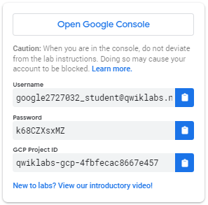
- Copy the username, and then click Open Google Console. The lab spins up resources, and then opens another tab that shows the Choose an account page.
Tip: Open the tabs in separate windows, side-by-side.
- On the Choose an account page, click Use Another Account.
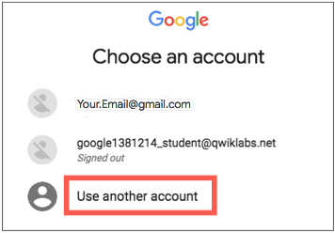
- The Sign in page opens. Paste the username that you copied from the Connection Details panel. Then copy and paste the password.
Important: You must use the credentials from the Connection Details panel. Do not use your Qwiklabs credentials. If you have your own GCP account, do not use it for this lab (avoids incurring charges).
- Click through the subsequent pages:
  - Accept the terms and conditions.
  - Do not add recovery options or two-factor authentication (because this is a temporary account).
  - Do not sign up for free trials.
After a few moments, the GCP console opens in this tab.
Note: You can view the menu with a list of GCP Products and Services by clicking the Navigation menu at the top-left, next to “Google Cloud Platform”. 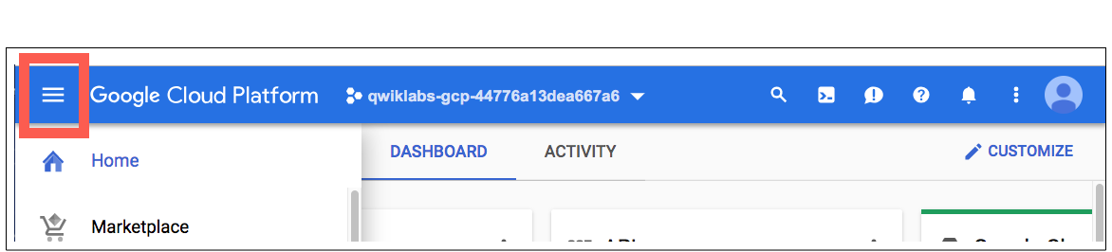

Create a Bucket
In the Console, go to Navigation menu > Storage > Browser. Click Create Bucket:
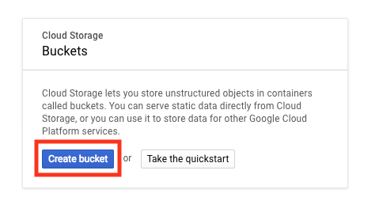
Name: Enter a unique name for your bucket.
Bucket naming rules:
- Do not include sensitive information in the bucket name, because the bucket namespace is global and publicly visible.
- Bucket names must contain only lowercase letters, numbers, dashes (-), underscores (_), and dots (.). Names containing dots require verification.
- Bucket names must start and end with a number or letter.
- Bucket names must contain 3 to 63 characters. Names containing dots can contain up to 222 characters, but each dot-separated component can be no longer than 63 characters.
- Bucket names cannot be represented as an IP address in dotted-decimal notation (for example, 192.168.5.4).
- Bucket names cannot begin with the "goog" prefix.
- Bucket names cannot contain "google" or close misspellings of "google".
- Also, for DNS compliance and future compatibility, you should not use underscores (_) or have a period adjacent to another period or dash. For example, ".." or "-." or ".-" are not valid in DNS names.
Storage class: Multi-Regional
Location: United States
Once you've gotten your bucket configured, click Create:
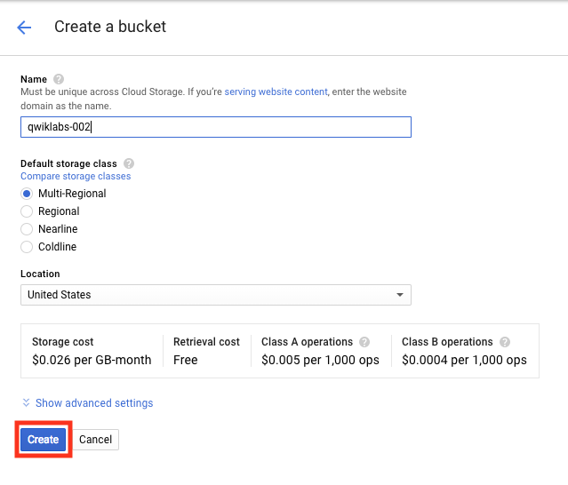
That's it — you've just created a Cloud Storage bucket!

Test Completed Task
Click Check my progress to verify your performed task. If you have successfully created Cloud Storage bucket, you will see an assessment score.
Create a bucket.
Check my progress

Test your Understanding
Below are a multiple choice questions to reinforce your understanding of this lab's concepts. Answer them to the best of your abilities.
Every bucket must have a unique name across the entire Cloud Storage namespace.
True

False
Cloud Storage offers four storage classes:
Coldline Storage
Cross region storage
Regional Storage
Local storage
Multi-Regional Storage
Nearline Storage
Submit

Upload an Object into the Bucket
In this section, you add an object to your bucket. For this lab the object is an image.
- Get an image. Click this link to an portrait of Ada Lovelace and save the image to your local computer.
- The Bucket details screen should still be open. Drag the portrait of Ada Lovelace to the Drop files here area of the Bucket details screen.
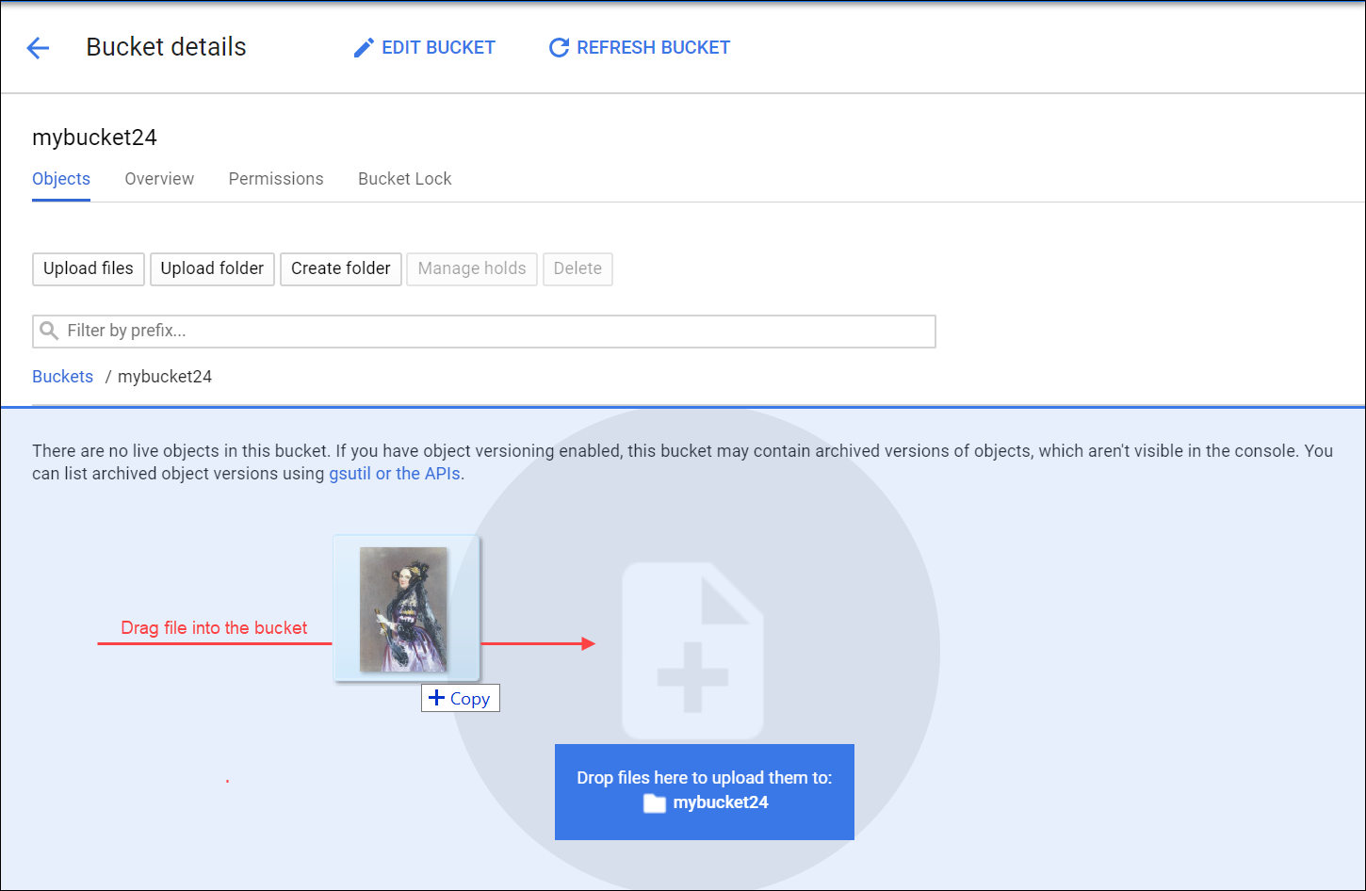
You should see the image listed in the Buckets list.
- Delete the image in the bucket. Check the box next to the filename then click Delete, and then click Delete again to confirm in the Delete selected file? dialog.
- Upload the image again, this time click Upload files.
- Navigate to the image on your local computer, and then click Open.
You should see the image listed in the Buckets list.
- Rename the file. Click on the drop-down menu (three vertical dots) on the far right on the image row and select Rename.
You may have to widen the browser window to see the drop-down menu (three vertical dots).
- Update the file name to "ada.jpg" and click RENAME.
You should now see one file, ada.jpg, in your bucket.

Test Completed Task
Click Check my progress to verify your performed task. If you have successfully uploaded object in your bucket, you will see an assessment score.
Upload an object into the bucket (ada.jpg)
Check my progress

Test your Understanding
Below are a multiple choice questions to reinforce your understanding of this lab's concepts. Answer them to the best of your abilities.
Object names must be unique only within a given bucket.
True

False

Share an Object Publicly
To create a publicly accessible URL for the object, click the drop-down menu (three vertical dots).
Select Edit permissions from the drop-down menu.
In the dialog that appears, click the + Add item button.
Add a permission for all users by entering in the following:
- Select User for the Entity.
- Enter allUsers for the Name.
- Select Reader for the Access.
Then click Save:
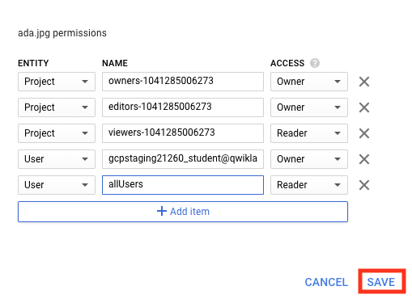
Once shared publicly, a link icon will appear in the public access column—click the link to open the file in a new tab.

Test Completed Task
Click Check my progress to verify your performed task. If you have successfully shared object publicly from your bucket, you will see an assessment score.
Share an ada.jpg object publicly.
Check my progress

Create Folders
In this section you create a folder.
- Click the "Create Folder" link near the top of the page.
- Name the folder folder1, then click Create.
You should see the folder in the bucket with a folder icon to distinguish it from objects:
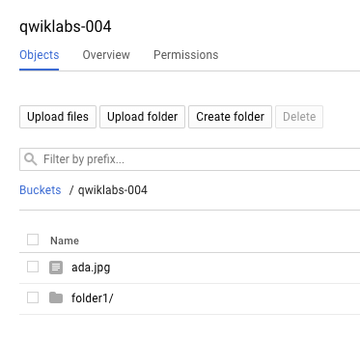

Create a subfolder
Now you'll create a folder inside folder1 and upload a file to it.
- Click on folder1, then click "Create Folder" near the top of the page.
- Name the folder folder2 then click Create.
- Click on created folder2.
- Drag the portrait of Ada Lovelace from your local computer and drop it into the Drop files here area.
After the file uploads, you see it listed in the subfolder in the bucket.
- Rename the file to "ada.jpg".
- To create a publicly accessible URL for the object, click the drop-down menu (three vertical dots) on the far right of the ada.jpg object.
- Select Edit permissions from the drop-down menu.
- In the dialog that appears, click the + Add item button.
- Add a permission for all users by entering in the following:
- Select User for the Entity.
- Enter allUsers for the Name.
- Select Reader for the Access.
- Then click Save:
Once shared publicly, a link icon will appear in the public access column—click the link to open the file in a new tab.
Who are you looking at? This is Ada Lovelace, credited with being the first computer programmer. She worked with mathematician and computer pioneer Charles Babbage, who proposed the Analytical Engine. Her interest in the Analytical Engine lead to translating a paper on the machine by Italian mathematician Luigi Menabrea, adding her own extensive annotations. These notes are considered the first computer program - an algorithm designed to be carried out by the machine. She developed a vision of the capability of computers, going beyond number crunching, and examined how individuals and society relate to technology as a collaborative tool. Citation: Ada Lovelace (last visited August 16, 2018).

Delete a folder
In this section you remove folder1 and its contents from your bucket.
- Navigate back to Buckets/[YOUR_BUCKET]. You should see folder1 listed in the bucket contents list.
- Check the box next to the Name, folder1 and click Delete, and then click Delete again when prompted to confirm.
folder1 and its contents are no longer in your bucket.

Congratulations!

